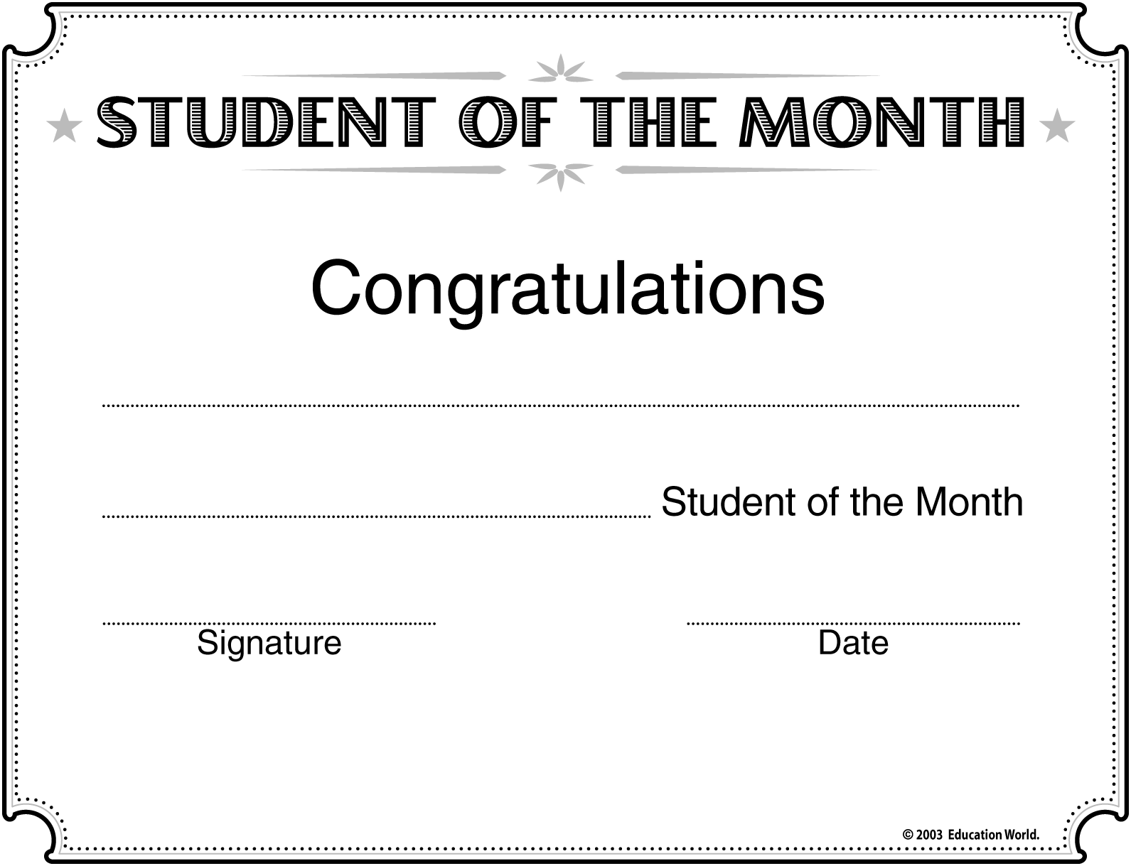
Maria Smith
Spanish

Madison Middle School –Ms. Antunes
